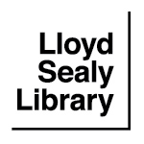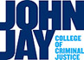

Reserve Item Request (one form per item)

Instructor name: Email:

Department: Course name/no.:

Term: Fall Winter Spring Summer Year:

For shelved items
(books or DVDs), to be checked out for use within the library for 3-hr. loans (for alternative loan periods, please contact the Reserve Librarian at libreserve@jjay.cuny.edu)

Library copy* OR Donation**

Title:

Call number:

Staff only – Barcode:

* Library-owned books will be returned to the circulating collection at the end of semester unless you request otherwise with reserve librarian.

**All personal copies are processed as library donations and will be given regular call number (not faculty surname). They may be reclaimed at the end of the semester. Contact the Reserves Librarian at libreserve@jjay.cuny.edu to arrange for pick up.

